|  |  |
| --- | --- |
| Nikon Z6 II  Máy ảnh Nikon Z6 II + Lens Z 24-70mm f/4 S  Nikon Z6 II Lens Z 24 70mm f4 S Nikon Z6 II Lens Z 24 70mm f4 S 5 Nikon Z6 II Lens Z 24 70mm f4 S 1 Nikon Z6 II Lens Z 24 70mm f4 S 2 | **Featured information:**  EXPEED image processor  24.5MP FX-format BSI CMOS sensor  Continuous shooting at 14fps, ISO 60-51200  UHD 4K30 Video  Price: $ 2200  **Specifications:**  Lens Mount  Nikon Z  Sensor Format  Full-Frame (1x Crop Factor)  Resolution  24.5 Megapixels  Size photo  6000 x 4000  Image Proportions  1:1, 3:2  Sensor Type  CMOS  Image Format  JPEG, Raw  Anti-Vibration  Sensor-Shift, 5-Axis |

**Overview:**

Nikon Z6 II is the successor to the Nikon Z6 mirrorless camera. Like the Nikon Z6, the Nikon Z6 II is designed entirely with Magnesium alloy to create sturdiness, durability, and comfort for the user. The camera is equipped with a 3.2-inch LCD screen, 2.1 million pixels combined with convenient buttons during use.

The camera delivers high-resolution images thanks to its 24.5MP Full-frame BSI CMOS sensor. The sensor can work in many different lighting conditions with ISO sensitivity from 100 - 51200, combined with 5-axis image stabilization in the camera body to help reduce vibration and noise for sharper handheld photos.

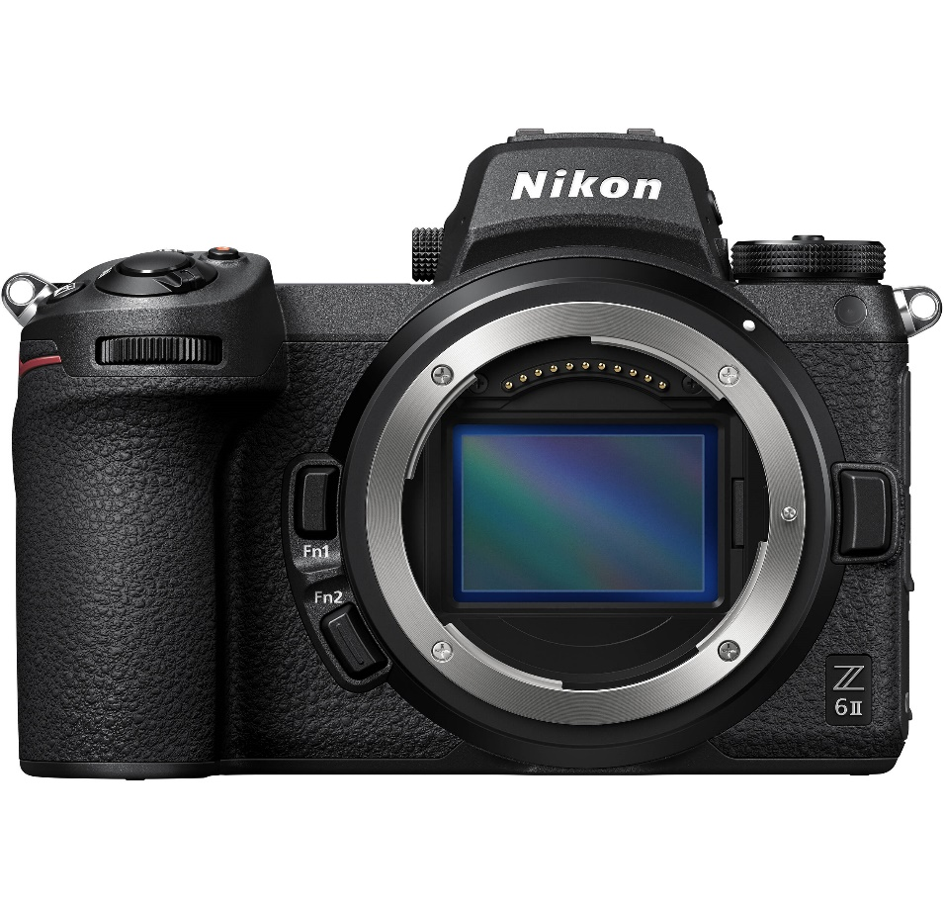

This sensor combined with the Dual Expeed image processor increases performance, allowing continuous shooting at 14 frames per second. At the same time, improving focus, reducing noise, providing high resolution images. In the Nikon Z6 II version, Nikon has improved autofocus capabilities to detect subjects accurately, capturing focus even on small details such as faces or animal eyes.

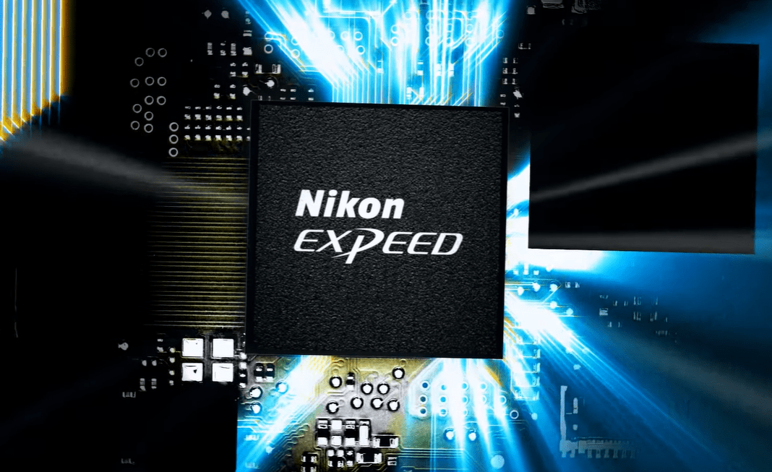

Located on the sensor is an array of 273 phase-detection autofocus points that cover 90% of the image area both vertically and horizontally. This helps the camera focus quickly and accurately, suitable for still photography and video recording. This focusing system can cover the entire frame to ensure accurate focus on objects at the edges of the frame. The built-in Hybrid AF system makes video recording smooth. This system will automatically switch with a phase-detection focusing system that provides fast, smooth focusing while recording.

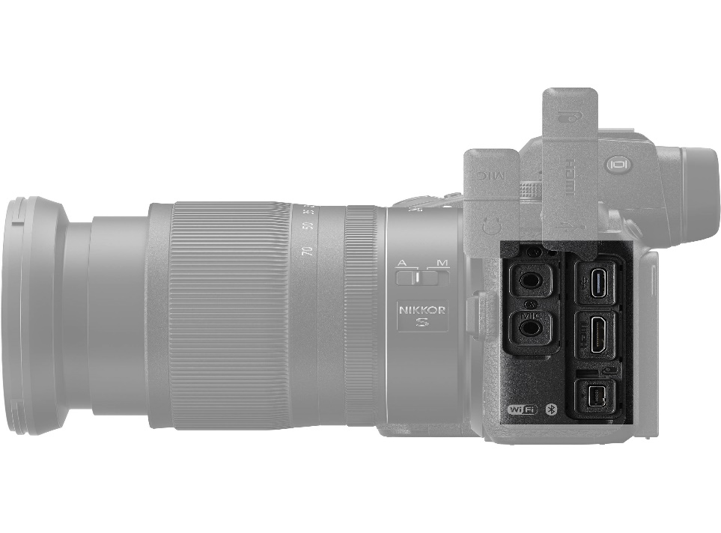

The integrated SnapBridge connection allows for quick file transfers, and it is also used to update the camera's programming. The camera has Bluetooth and Wi-Fi connectivity for easy file exchange with smartphones. Thanks to this feature, the phone can view images directly on the camera and can work remotely easily.